Cassandra Program 1 :-

Perform the following DB operations using Cassandra.

1. Create a key space by name Employee

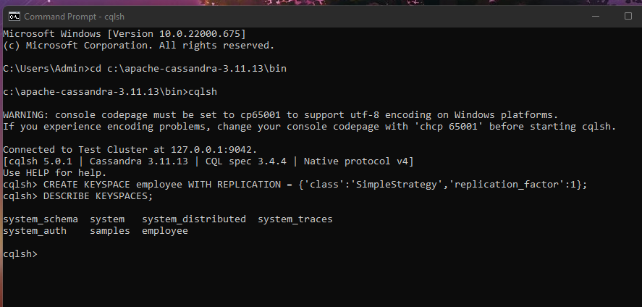

2. Create a column family by name Employee-Info with attributes Emp_Id Primary Key, Emp_Name,

Designation, Date_of_Joining, Salary, Dept_Name

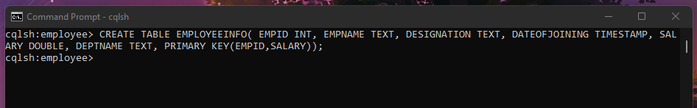

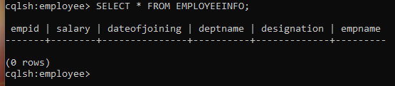

3. Insert the values into the table in batch

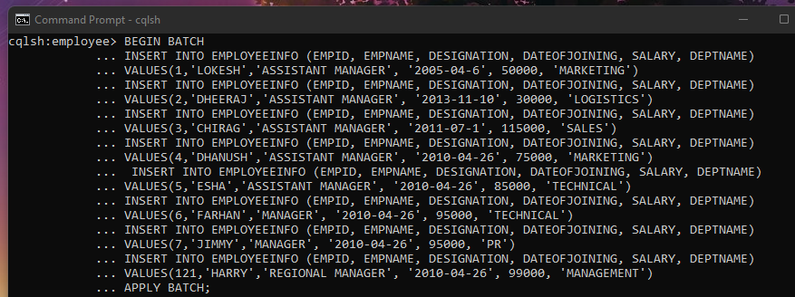

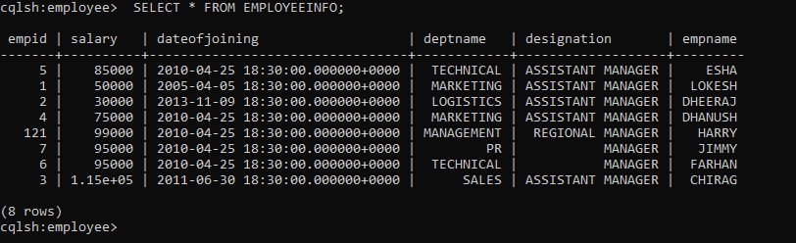

4. Update Employee name and Department of Emp-Id 121

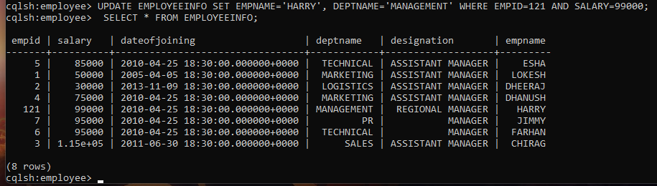

5. Sort the details of Employee records based on salary (Note:- cql>PAGING OFF)

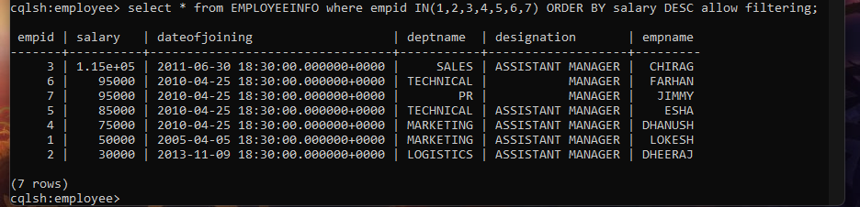

6. Alter the schema of the table Employee_Info to add a column Projects which stores a set

of Projects done by the corresponding Employee.

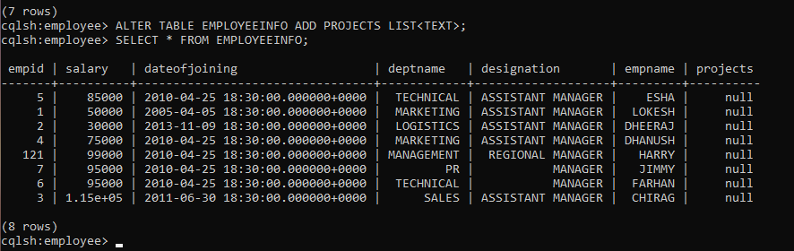

7. Update the altered table to add project names.

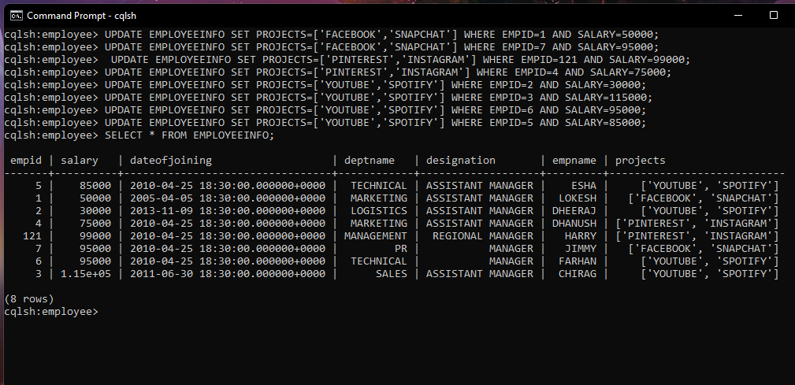

8. Create a TTL of 15 seconds to display the values of Employees.

//BEFORE 15 seconds

